**Insurance Analysis Report**

**Introduction**

Medical insurance is a financial concern for people and families. There are different personal, behavioral, and geographical factors that go into the cost of these insurances that insurance companies base their premiums on. Insurance companies and policyholders alike need to know what factors determine insurance costs.

**Problem Statement**

The purpose of this report is to examine a dataset with several key fields, including age, sex, BMI (Body Mass Index), number of children, smoking, and region, to see how these factors can affect medical insurance rates. We will use Tableau data visualization tools to explore patterns, and correlations, and find the greatest predictors of large insurance bills. Extra focus will be placed on the relationship between healthcare costs and lifestyle factors such as smoking and BMI. This study seeks to give some suggestions to the insured about how controllable factors might lower their medical cost and to the insurer some ideas on how to calculate premiums better. In examining these relationships, I hope to offer a thorough analysis of how personal attributes and behaviors impact medical insurance bills.

**Questions Related**

* In what way does the average medical insurance cost rise with age?
* Is there a specific age when medical charges start surging?
* What is the particular BMI category that has been most likely to show a higher incidence of Medical insurance expenditure?
* Does obesity, defined by a BMI greater than some value (30), add considerably to charges?
* How much do some geopolitical areas reveal higher expenditures on medical insurance as counterbalanced to others? If so, what could be to blame for these differences?
* To what extent does BMI link with a region on health care expenses

**Exploratory Data Analysis**

This study is based on insurance data, which includes various factors such as age, sex, location, BMI, smoking history, and previous medical charges. The purpose is to examine the relationship between these variables and the amount of money individuals are charged for medical services. Some observations from the data include:

**Age and Charges**

The average age in the data set is about 39 years, and the charges for this age are about $13,270. This means that people of middle age will have large medical costs as shown in Figure 1.

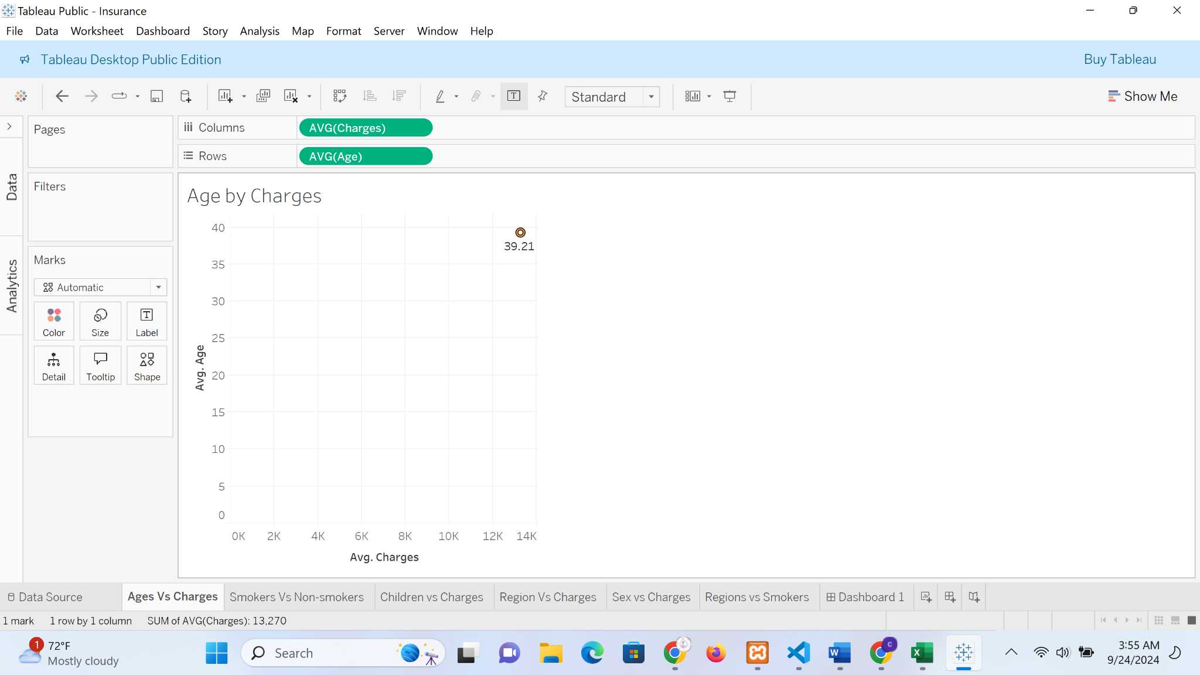

Figure 1. Tableau screenshot-Ages by Charges

**Sex vs Charges**

When comparing the total medical charges between the sexes there is a slight difference, with males incurring slightly higher charges than females. Males incurred around $8.32 million as shown in Figure 2. However, further statistical analysis is required to asses the differences.

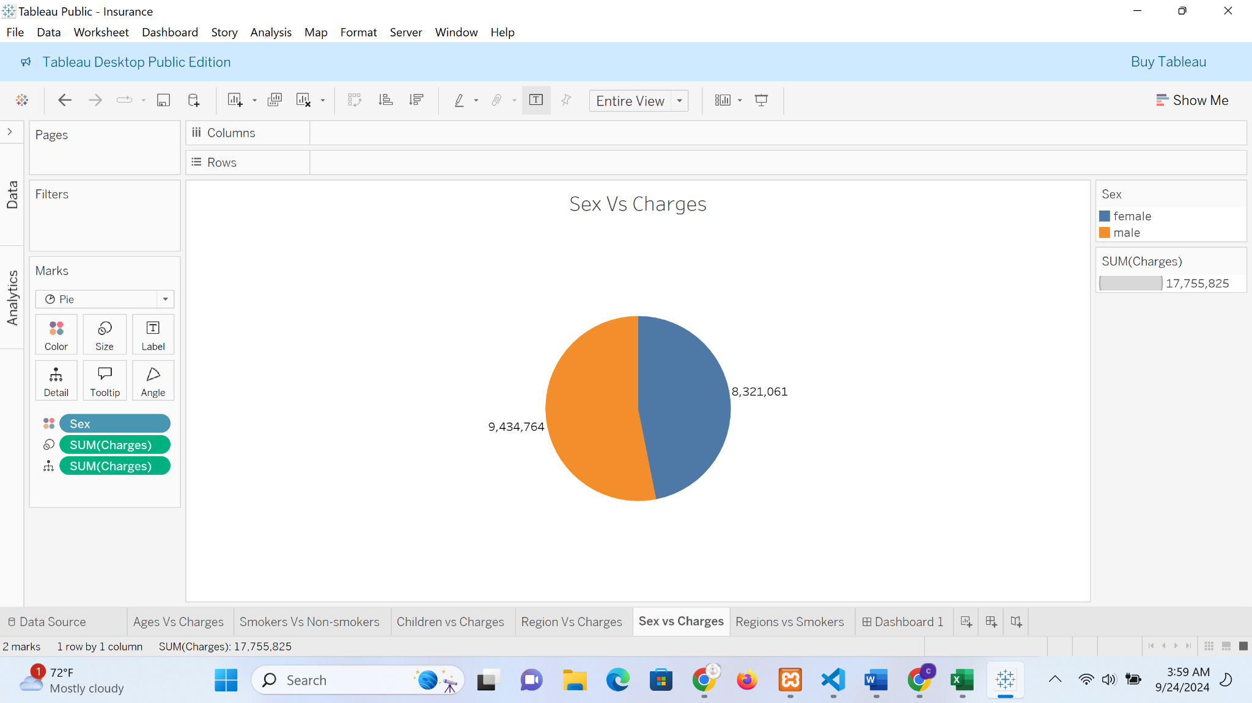

Figure 2. Tableau screenshot-Sex by Charges

**Regions vs Charges**

The medical charges differ by region, with the southeast having the highest medical charges, followed by the northeast as shown in Figure 3. The southeast's higher charges suggest that individuals in this region have greater medical needs or higher healthcare costs.



Figure 3. Tableau screenshot-Regions by Charges

Overall, this exploratory data analysis has provided useful insights into the factors that affect medical bills. The data shows correlations between age, sex, area, BMI, and medical cost. More statistical analysis would be needed to explore these relationships.

**Univariate Analysis**

**Age vs Charges**

Age is an important factor influencing medical insurance charges. As seen in Figure 4, a scatter plot of age vs. charges, charges rise as age increases, particularly after the age of 40. This implies that older people tend to have more medical expenses because they are more likely to have medical problems that are age-related.

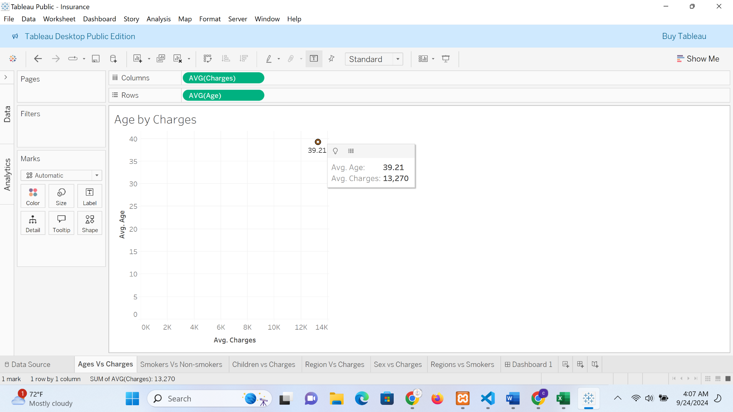

Figure 4. Tableau screenshot-Ages by Charges

**BMI and Charges**

Individuals with higher BMIs tend to spend more medically because higher BMIs are usually associated with medical problems like obesity-related diseases. This implies that people with a higher BMI have more medical expenses, which supports the correlation between obesity and medical costs as shown in Figure 5.

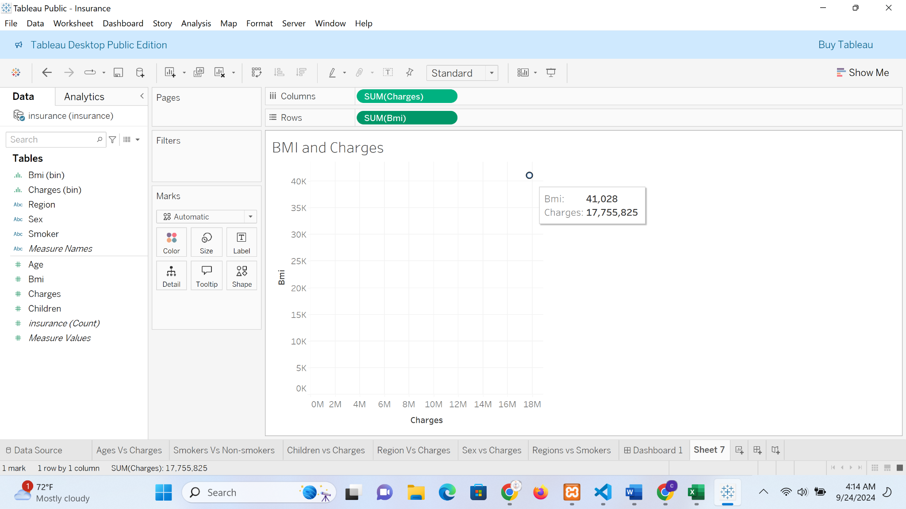

Figure 5. Tableau screenshot- BMI and Charges

**Smokers vs Non-Smokers**

Smokers have significantly higher medical charges compared to non-smokers as shown by a pie chart in Figure 6. This implies that medical costs for smokers are significantly higher, with the interquartile range for smokers being at a higher level than that of nonsmokers. That difference should illustrate the extra health problems and expenses incurred by smoking such as lung cancer and heart disease.

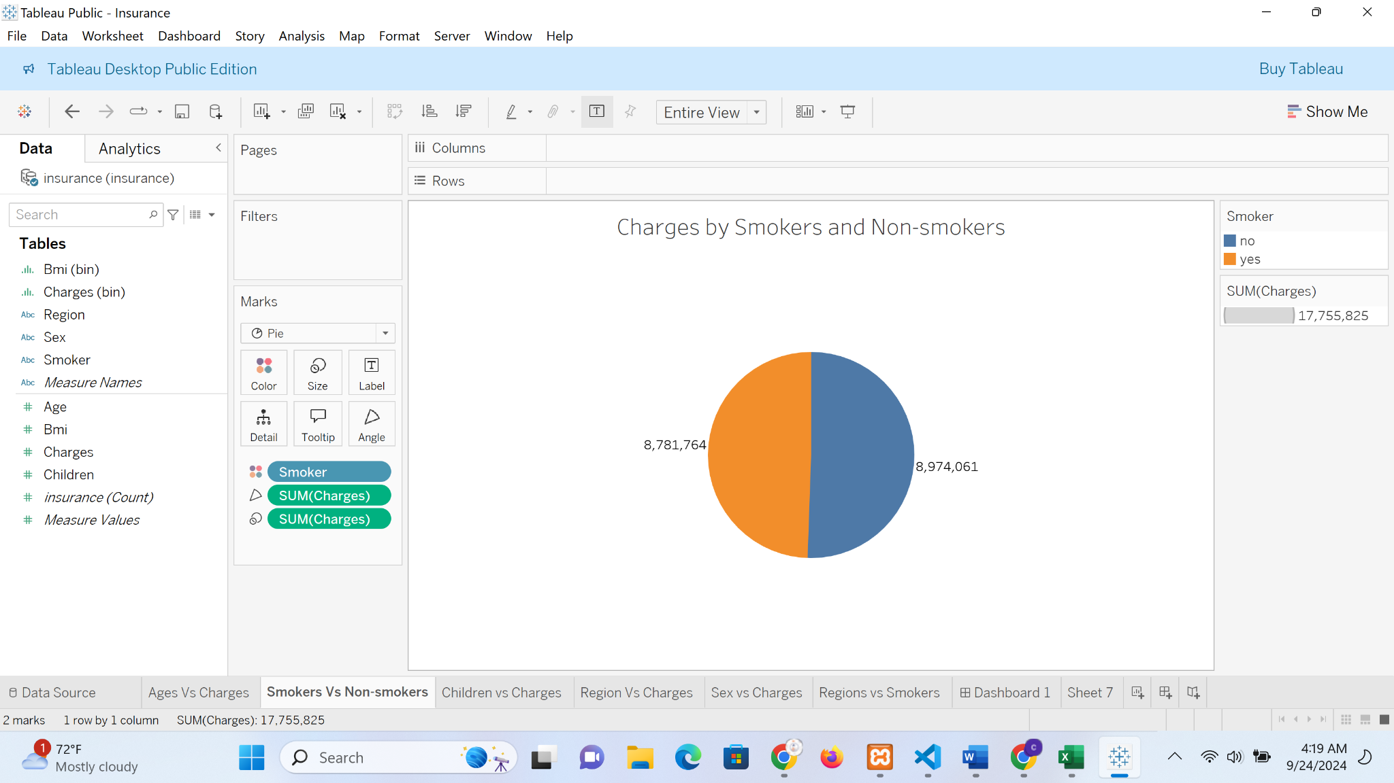

Figure 6. Tableau screenshot- Charges by Smokers and Non-smokers

**Bivariate Analysis**

**BMI and Region vs. Charges**

A comparison between BMI and region shows geographical differences in the way BMI affects medical expenses. As can be seen in Figure 7, insurance rates are much higher in areas such as the Southeast where the average BMI also tends to be higher. This implies that people in fatter parts of the country have more medical problems and therefore more medical expenses. On the other hand, places such as the northeast, which has an average lower BMI. This relationship sheds light on the geographical lifestyle factors of diet activity levels and healthcare infrastructure that are associated with BMI-related healthcare costs.

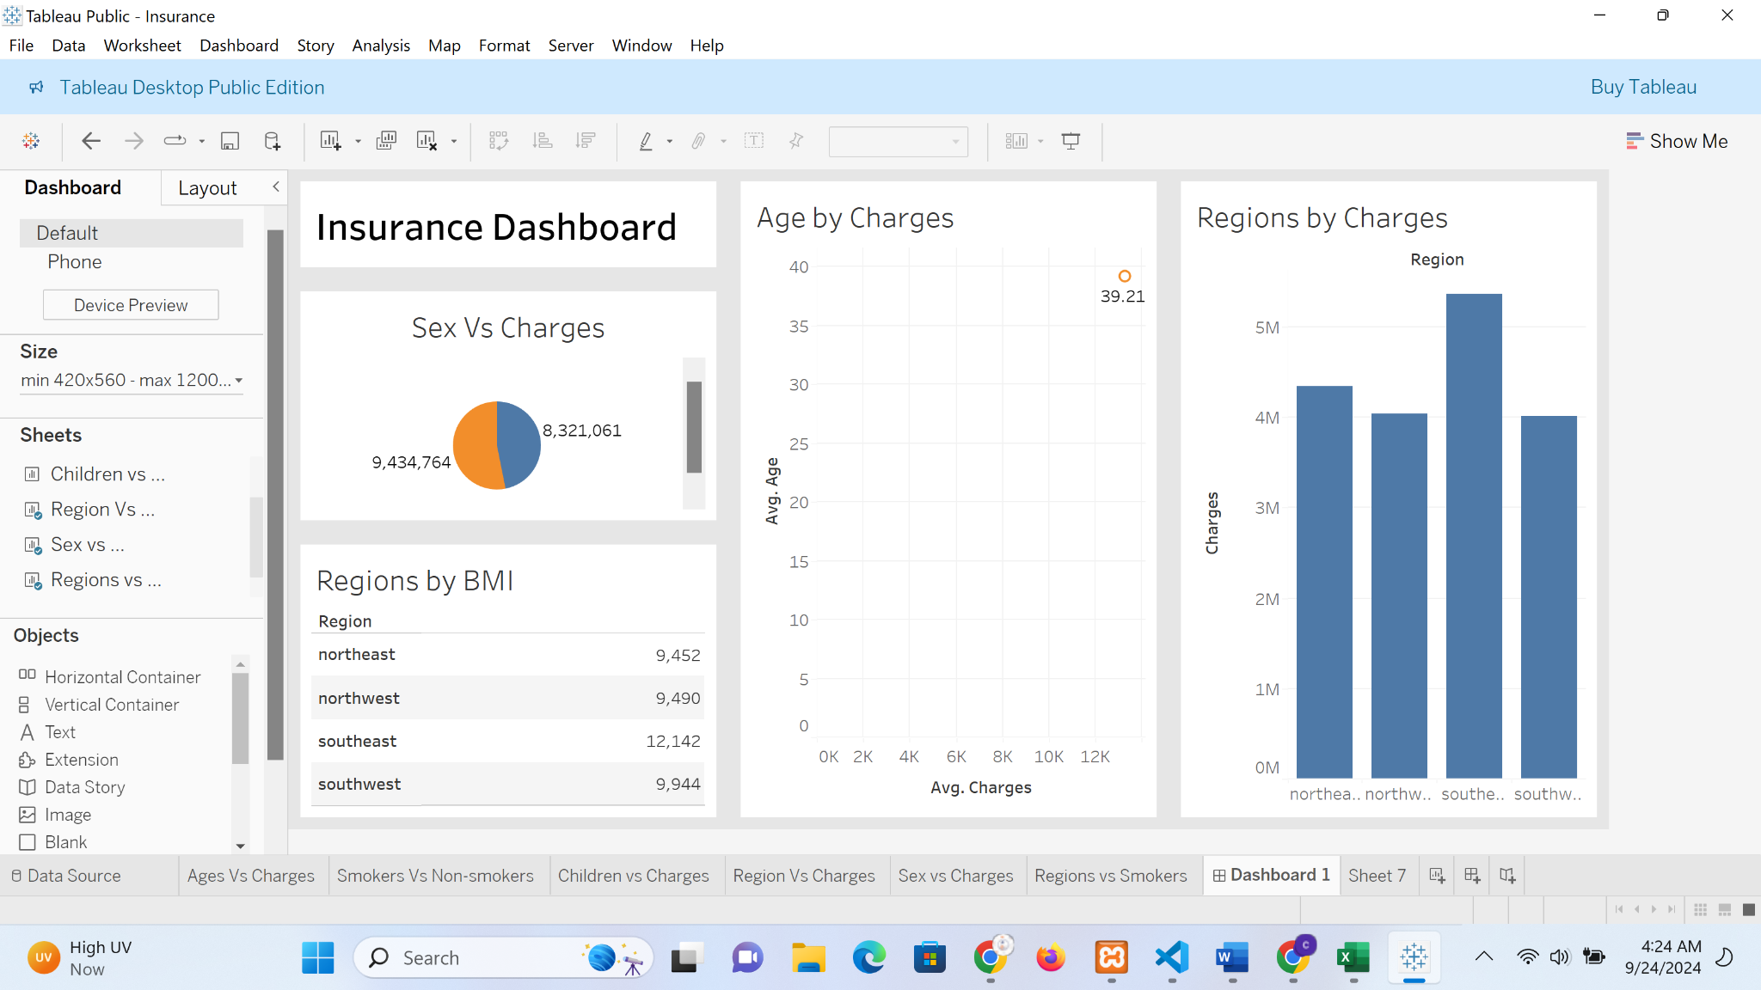

Figure 7. Tableau screenshot- Regions by BMI

**Sex vs. Charges**

When comparing medical charges between men and women, the analysis indicates that men tend to incur higher charges overall as shown in Figure 8. Men who smoke always cost more in medical expenses than women who smoke, probably because smoking-related diseases affect men more. Also, men with more kids may have slightly higher charges, possibly due to family medical responsibilities. On the other hand, women with children may have lower medical charges, possibly due to preventive care and maternal health programs. Overall, gender discrepancies in fees are due to smoking, and family structure.

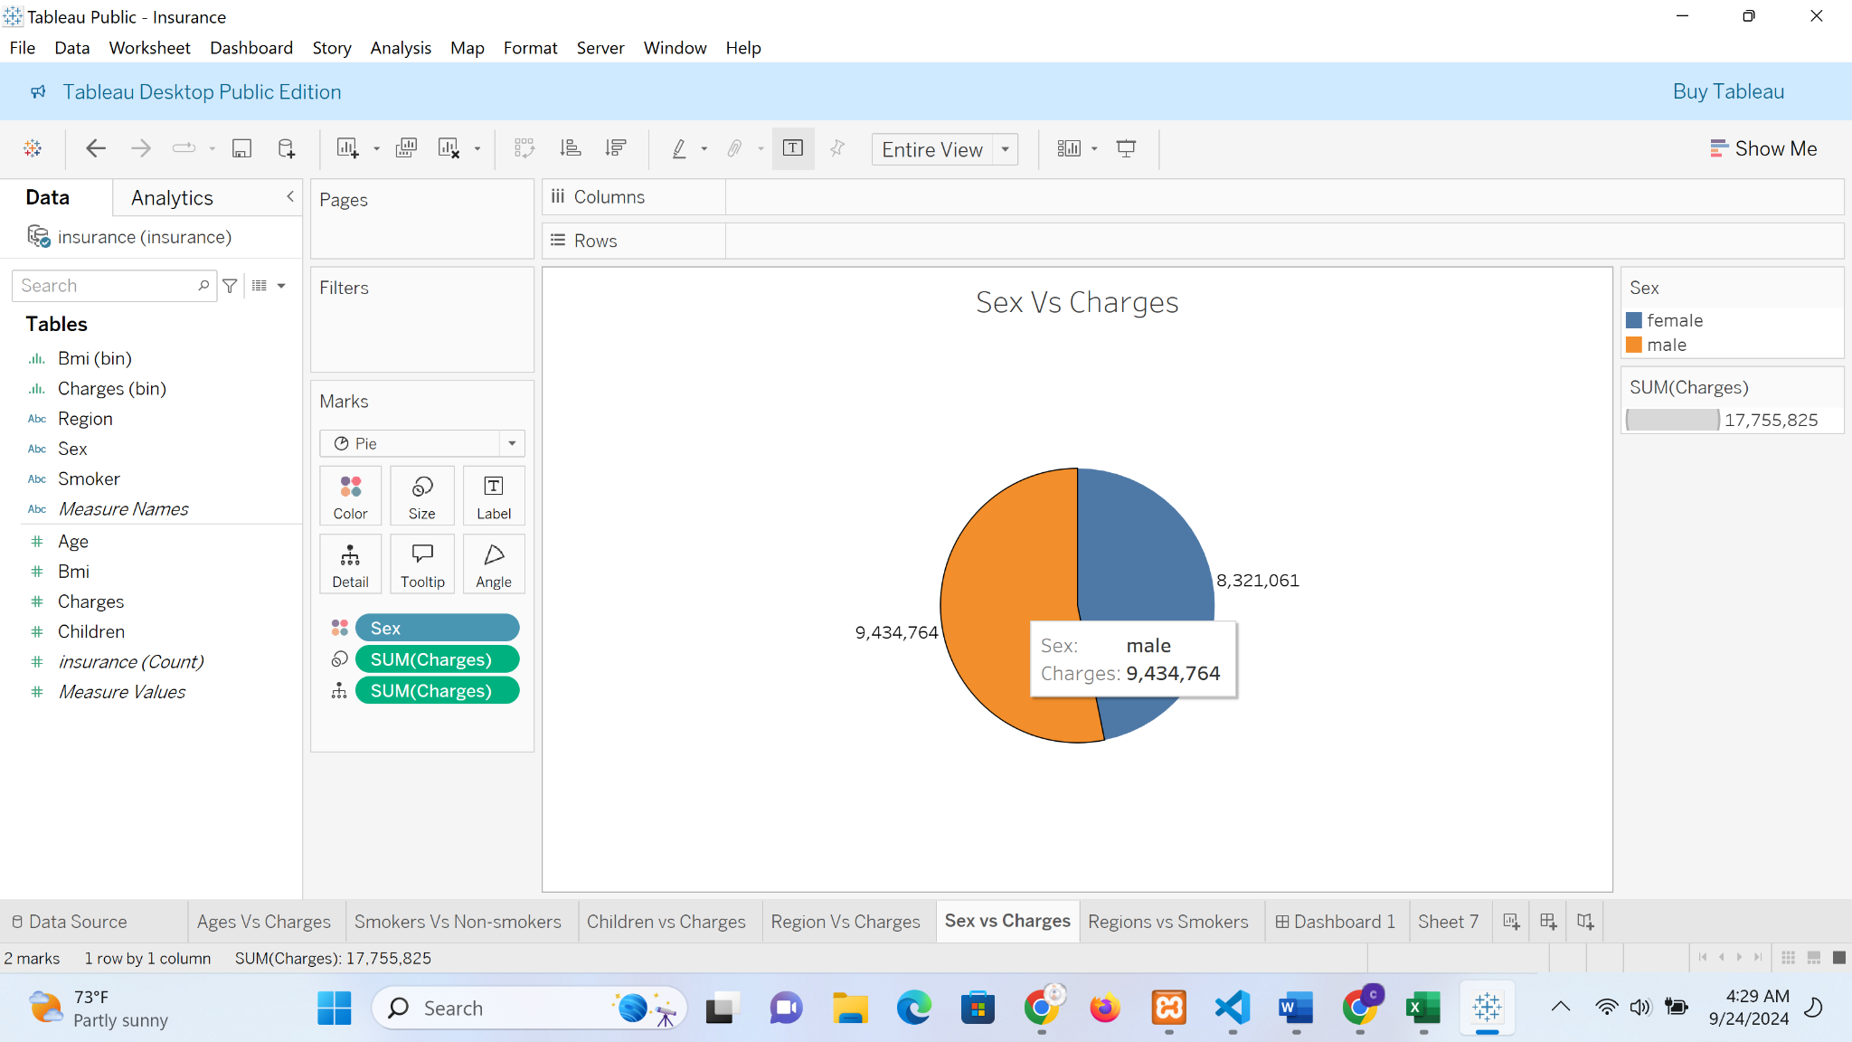

Figure 8. Tableau screenshot- Sex by Charges

**Key Findings**

Smoking status emerged as the most significant predictor of higher medical costs. Smokers pay a lot more though, like 50% more than nonsmokers. Smoking is the first and most important factor, because of the negative health effects such as heart disease and cancer, which are very expensive to treat, making it very expensive to insure. BMI is another predictor, especially if it is over 30, suggesting an aspect of obesity. A higher BMI costs more medically because as the BMI rises, so do the chances of having hypertension, diabetes, and cardiovascular diseases.

Age plays a notable role in predicting insurance costs, with older individuals generally facing higher charges. As people age they have more medical problems f. Lastly, although region plays a role in costs, it is not as significant as smoking and BMI. However, the southeast region showed consistently higher charges, possibly reflecting regional lifestyle factors like higher BMI and smoking rates, as well as variations in healthcare costs. These factors highlight the complex interplay between lifestyle, health status, and demographic variables in determining insurance charges.

**Conclusion and Recommendations**

The analysis highlights that smoking and high BMI are the two largest contributors to medical insurance expense. Individuals can potentially reduce their medical expenses by adopting healthier lifestyle choices, such as quitting smoking and managing their weight. Lowering BMI, especially in obese individuals, would in turn lower the risk of chronic disease, and thus lower medical cost in the long run.

For the insurance companies, the findings can help them to make informed decisions, especially on premium calculations. Smokers, and overweight people should be rated as higher risk insured, and therefore pay more. Also, insurers could create specialized wellness programs specifically for quitting smoking, and losing weight. These programs would not only lower medical claims, but they would also encourage better lifestyles for the insured, which would benefit both parties in the long run.

Insurers should give discounts or incentives to those who participate in wellness programs driving aspect of it is a win-win situation, where the policyholder is taking steps to become a healthier person and the insurer is minimizing the risk of claims.